CEN/TC
Date: 2014-05
TC WI
CEN/TC
Secretariat:
Business Interoperability Interfaces for public procurement in Europe — BII profile 21 — Statement
Einführendes Element — Haupt-Element — Ergänzendes Element
Élément introductif — Élément central — Élément complémentaire

ICS:
Descriptors:
CWA XXX is a technical agreement, developed and approved by an open, independent Workshop structure within the framework of the CEN-CENELEC system.
CWA XXX reflects the agreement only of the registered participants responsible for its content, and was developed in accordance with the CEN-CENELEC rules and practices for the development and approval of CEN/CENELEC Workshop Agreements.
CWA XXX does not have the status of a European Standard (EN) developed by CEN and its national Members. It does not represent the wider level of consensus and transparency required for a European Standard (EN) and is not is not intended to support legislative requirements or to address issues with significant health and safety implications. For these reasons, CEN are not accountable for the technical content of CWA XXX or for any possible conflicts with national standards or legislation.
The Workshop participants who drafted and approved CWA XXX are indicated in the Foreword.
The copyright in CWA XXX is owned exclusively by CEN. Copies of CWA XXX are available from the national standards bodies of the following countries: Austria, Belgium, Bulgaria, Croatia, Cyprus, Czech Republic, Denmark, Estonia, Finland, Former Yugoslav Republic of Macedonia, France, Germany, Greece, Hungary, Iceland, Ireland, Italy, Latvia, Lithuania, Luxembourg, Malta, Netherlands, Norway, Poland, Portugal, Romania, Slovakia, Slovenia, Spain, Sweden, Switzerland, Turkey and the United Kingdom.

Contents
Page
1 Scope 5
1.1 Introduction 5
1.2 Goals 5
1.3 Business environment 5
2 Requirements 6
2.1 Process requirements 6
Common business processes 6
2.2 High level business requirements 7
2.3 Key examples 7
2.3.1 Example 1 7
2.3.2 Example 2 7
3 Profile detailed description 8
3.1 Processes in scope 8
3.2 Roles involved 8
3.3 Statement business process 9
3.3.1 Business process rules 12
3.4 Transaction information requirements 12
3.4.1 Statement Transaction 12
3.4.1.1 Statement transaction business requirements 12
3.4.1.2 Statement Transaction Information Requirements 14
3.4.1.3 Statement Transaction Business Rules 19
4 Implementation 21
5 References 21

Foreword
CWA 5678 part 113, BII Profile 21 – Statement was developed in accordance with CEN-CENELEC Guide 29 “CEN/CENELEC Workshop Agreements – The way to rapid agreement” and with the relevant provisions of CEN/CENELEC Internal Regulations - Part 2. It was agreed on YYYY-MM-DD in a Workshop by representatives of interested parties, approved and supported by CEN following a public call for participation made on YYYY-MM-DD. It does not necessarily reflect the views of all stakeholders that might have an interest in its subject matter.
The final text of CWA 5678 was submitted to CEN for publication on YYYY-MM-DD. It was developed and approved by:
- Agenzia delle entrate – Sistema di Interscambio (IT)
- AVCP - Autorità per la Vigilanza sui Contratti Pubblici di Lavori, Servizi e Forniture (IT)
- BME e.V. (DE)
- CEN/WS eCAT, Liaison
- Columbus Denmark A/S (DK)
- Cloudia Oy (FI)
- Danish Agency for Digitisation (DIGST) (DK)
- DIFI (NO)
- Direction de l'information légale et administrative (DILA) (FR)
- ETSI, Liaison
- Flowcanto (NL)
- GS1 in Europe (NL)
- Highjump Software (DK)
- ICEPRO (IS)
- Invinet Sistemes 2003 (ES)
- Laszlo Ketszeri (HU)
- Nets Norway AS (NO)
- Nexus IT (ES)
- Phast (FR)
- PIANOo Dutch Ministry of Economic Affairs (NL)
- Publications Office of the European Union (LU)
- Single Face To Industry (SFTI) (SE)
- SKI A/S (DK)
- SOGEI (IT)
- University of Koblenz-Landau (DE)
- University of Piraeus Research Center (UPRC) (GR)
- Western Norway Regional Health Authority (NO)

It is possible that some elements of CWA 5678 may be subject to patent rights. The CEN-CENELEC policy on patent rights is set out in CEN-CENELEC Guide 8 “Guidelines for Implementation of the Common IPR Policy on Patents (and other statutory intellectual property rights based on inventions)”. CEN shall not be held responsible for identifying any or all such patent rights.
The Workshop participants have made every effort to ensure the reliability and accuracy of the technical and non-technical content of CWA 5678, but this does not guarantee, either explicitly or implicitly, its correctness. Users of CWA 5678 should be aware that neither the Workshop participants, nor CEN can be held liable for damages or losses of any kind whatsoever which may arise from its application. Users of CWA 5678 do so on their own responsibility and at their own risk.
This CEN Workshop Agreement (CWA) has been drafted and approved by the Workshop on Business Interoperability Interfaces for Public procurement in Europe (BII), phase 3.
CWA 5678 is part of a set of CWAs prepared by CEN/WS BII3:
CWA 1234:2016 BII Architecture
CWA 2345:2016 BII Notification profiles and transactions
CWA 3456:2016 BII Tendering profiles and transactions
CWA 4567:2016 BII Catalogue profiles and transactions
CWA 5678:2016 BII Post-award profiles and transactions

CWA 5678 part 113 replaces CWA 16558:2012, annex B.
The CEN Workshop members who have contributed to the development of this document are:
Name | Affiliation | Country
Martin Forsberg | SFTI | SE
Fred van Blommenstein | Flowcanto | NL
Jostein Frømyr | DIFI/Edisys | NO
Douglas Hill | GS1 in Europe | DK
Sven Rasmussen | DIGST | DK
Ole Madsen | DIGST | DK
Gerardo De Caro | Agenzia Delle Entrate (Italian Tax Agency) | IT
Antonia Caressa | SOGEI | IT
Raffaella Migliorini | SOGEI | IT
Tadeusz Rudnicki | GS1/ILIM | PL
Toruk Kraska | GS1/ILIM | PL
Jan Bo Sorensen | High Jump | DK
Oriol Bausa Peris | Invinet | ES
Enric Staromiejski | Everis | ES
Jan Mærøe | DIFI | NO
Frank-Dieter Dorloff | BME/University of Duisburg-Essen | DE
Cecille Guasch | European Commission | BE
Marius Juganaru | European Commission | BE
Olav Kristiansen | Difi | NO
Søren Pedersen | ESV | SE
Anders Kingstedt | ESV/OpenPEPPOL | SE
Nicoletta Lippi | SOGEI | IT
Georg Birgisson | Midran | IS
Edmund Gray |  | IR
Yildiray Kabak | SRDC | TR
Natascha Rossner | GS1 in Europe | FR
Thomas Pendrup | Evenex | DK
Morten Gjestad | Nets | NO
Siw Midtgård Meckelborg | Edisys | NO
Erik Gustavsen | Edisys | NO
Ivana Gargiulo | CBI | IT
GiampaoloSellitto | ACVP | IT
Veit Jahns | BME/University of Duisburg-Essen | DE
Massimo Battistella | AITI | IT
Tomas Tluchor | GS1 in Europe | CZ
Chiara Lombardo | Tesoro | IT
Fabio Jorrentino | CBI | IT
Cristian Falasca | CBI | IT
Thomas Pettersson | SFTI | SE
Roberto Corona | Ministry for the Economy and Finance | IT
Thomas Small | European Commission | BE
Peter Boressen | Clearview Trade | DK
Elisa Bertocchi | Intercenter | IT
Tim McGrath | OASIS UBL TC | AU
Soren Lennartsson | SFTI | SE
Laszlo Ketszesi | LKP | HU
Peter Bove | SKI | SE
Marius Juganaru | European Comission | BE
Jörg Richter | Gefeg | DE

This document was edited by:
Name | Role | Country
Oriol Bausa | Technical Editor | ES
Georg Birgisson | Technical Editor | IS
Jostein Frømyr | Vice-Chair CEN/BII | NO
Fred van Blommestein | Technical Editor | NL
Yildiray Kabak | Technical Editor | TR
Edmund Gray | Technical Editor | EI
Carmen Ciciriello | Technical Editor | IT
Introduction
The CEN BII Workshop was established in May 2007 with the objective of harmonising electronic public procurement in Europe. The BII Workshop is a standardisation initiative within CEN (European Committee for Standardisation). It provides a framework for interoperability in pan-European electronic transactions expressed as a set of technical specifications ("Profiles"). Profiles are designed to facilitate effective public e-procurement based on a modular approach for implementation, with a focus on global interoperability.
BII Profiles can be seen as “agreements” on message contents and business processes. The profile descriptions focus on the core information elements that typically cater to the majority of user requirements applicable across Europe and lower the need for detailed bilateral agreements between the trading partners.
More information about the BII initiative can be found in CWA 1234:2015 and on www.cenbii.eu.

Scope

Introduction
The statement document enables the supplier to provide an overview of a customer account over a specific period of time and optionally claim payment for outstanding balance. A Statement process cannot replace the billing process since a statement document is not a billing document.

Goals
The goals to be supported by implementing this profile are:
ID | Description
G21-001 | Provides a basis for automated handing of statements in a semi manual environment.
G21-002 | Suppliers can offer their trading partners the option of standardized documents in a uniform way and thereby move all their statements into electronic form.
G21-003 | Customers can receive overview of their customer account in an efficient way.
G21-004 | The statement provides summary of issued billing documents with the optional purpose to claim payment. Excellent aid to reconciliation of accounts.
G21-005 | For economic operators: potential for shortened payment cycle and improved cash flow.
G21-006 | For purchasing authorities: fast and efficient way of clearing debts between the business partners.

Business environment
This profile is intended to support transmission of electronic documents for processing in semi automated processes by the receiver. The intended scope for this profile includes:
- B2B and B2G
- Common business processes for cross industry and cross border invoicing
- Regional procurement within EU and EEA. The profile is expected to be applicable to other regions following a review of regional requirements.
The transactions, specified in this profile are intended to be exchanged between the application systems of customers and suppliers. This means that it is expected that customers and suppliers have connected their systems to the internet, and that they have middleware in place to enable them to send and receive the transactions in a secure way, using an agreed syntax.

Requirements

Process requirements
The Supplier sends an electronic statement that can be received and processed by the Customer.
The statement document enables the supplier to provide an overview of a customer account over a specific period of time and optionally claim payment for outstanding balance. A statement is informative and does not affect the underlying information. As an example, if a correctly issued invoice is missing from a statement that omission does not affect the Debtors obligations to that invoice.

Common business processes
This section identifies the major business processes that are frequently supported by billing and will clarify if and how they are supported in this profile. This profile supports a “common business process” that is used widely or understood as being relevant for most companies. The main activities supported by this profile are:
Accounting
Accounting is not an objective of the statement; it is used for providing status and overview of customer account over a specific period of time. It therefore serves and as an aid to reconciliation of accounts when resolving differences, for example in issued invoices and payments between parties.
The statement is NOT a billing document.
Approval
The process of approving invoices or credit not is only partially in scope. Statement can be routed in-house as basis for approving partially or fully the underlying transactions.
VAT reporting
Since the statement is not a billing document and does not report on VAT this process is not in scope.
Payment
By stating transaction on customer account over a period of time, the statement can serve as basis for requesting payment for outstanding difference. It therefore provides for information about payment terms and payment means for supporting payment process within the buyer organisation.
Therefore, like Invoices, a statement should identify the means of settlement and clearly state what payment is requested. They should provide necessary details to support bank transfers in accordance with the SEPA initiative. They may provide information for relating an invoice to a payment card used for settlement. Additionally statement should support basic information for national payment systems for use in domestic trade.
Direct debits, in accordance with SEPA initiative, are out of scope for the statement since the use of directs debit are dependent on prior contractual agreement between the buyer and the seller.

High level business requirements

Key examples

Example 1
A buyer has a monthly customer account (a line of credit) with a seller. According to agreement each purchase during the month is invoice and the invoice is credited to the customer's account. Any credit notes issued as debited against the account. When the customer pays into his account the payments are debited to the account. At the end of the month the seller issues a statement that shows all transactions made into the account during the month. The statement may serve as a claim for payment of the account balance and it may be used by the buyer to reconcile against the transaction in his own purchasing system.

Example 2
For auditing purposes party may request seller to issue a statement showing all transactions during a period made to a particular customer account. The auditing party may use the statement to reconcile the accounts being audited.

Profile detailed description

Processes in scope
Procurement is a complex domain with several key processes, some of which are illustrated in the following figure.
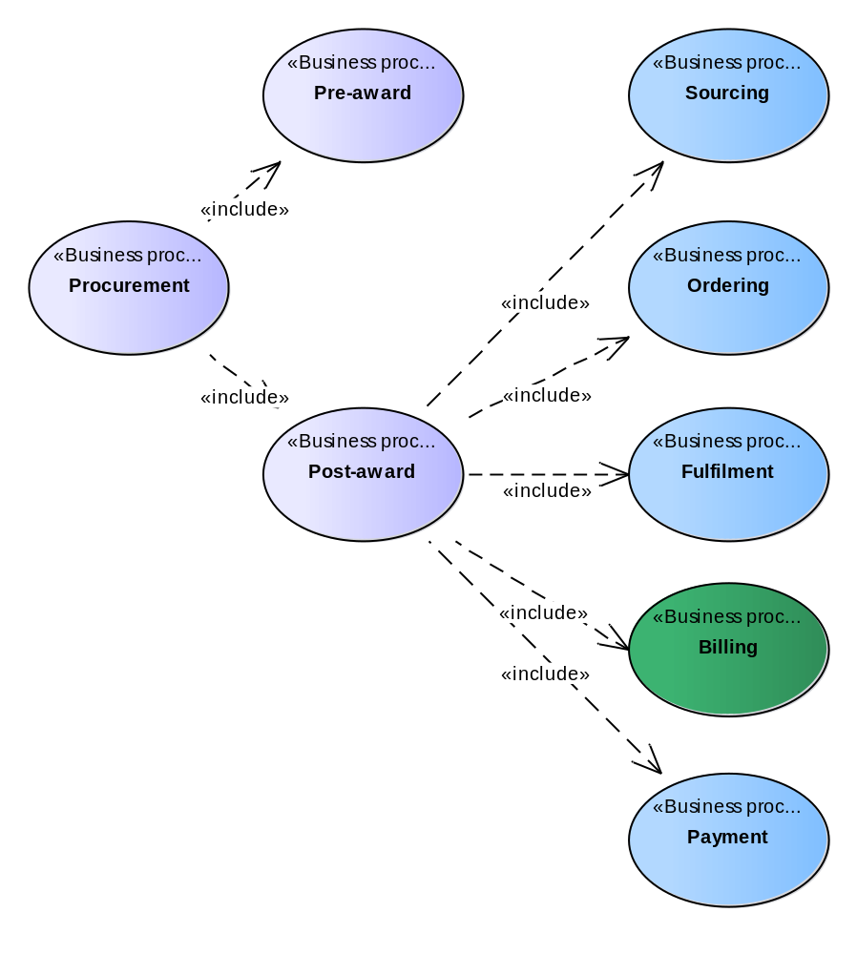

The Invoice Only profile covers the business processes as highlighted in the above figure.

Roles involved
The following business partners participate in this profile, acting in the roles as defined below.
Business partner | Description
Customer | The Customer is the legal person or organization who is in demand of a product or service.  Examples of Customer roles: buyer, consignee, debtor, contracting authority.
Supplier | The Supplier is the legal person or organization who provides a product or service.  Examples of Supplier roles: seller, consignor, creditor, economic operator.

Role/actor | Description
Creditor | One to whom a debt is owed. The Party that claims the payment and is responsible for resolving billing issues and arranging settlement. The Party that sends the invoice and/or statement.  Also known as statement Issuer, Accounts Receivable, Seller.
Debtor | One who owes debt. The Party responsible for making settlement relating to a purchase.  The Party that receives the Invoice or statement.  Also known as statement receiver, Accounts Payable, Buyer.

The following diagram links the business processes to the roles performed by the Business Partners.
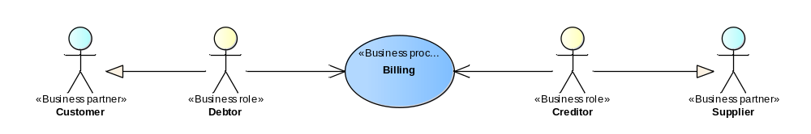

Statement business process
The following diagram shows the choreography of the business process implemented by the profile. The choreography of business collaborations defines the sequence of interactions when the profile is run within its context. 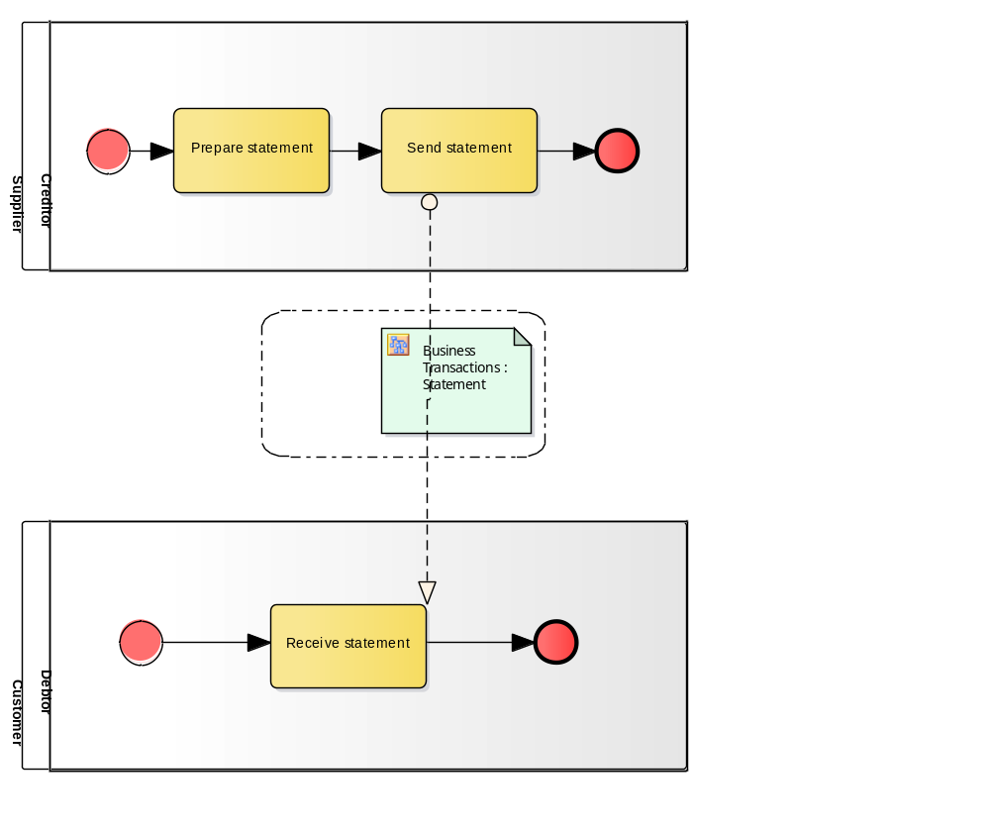
Categories | Description and Values
Description | The Supplier sends an Invoice or a Credit Note to the customer.  There can be dispute scenarios of: overcharge, undercharge or incorrect information. The creditor corrects the disputed invoice either:  - By issuing a Credit Note,  - By an additional Corrective Invoice,  - By cancelling the original Invoice by means of a Credit Note and issuing a new Corrective Invoice.  - By providing additional documentation.
Pre-conditions | The Customer and the Supplier have identified each other.  The Customer has agreed to accept electronic invoices and electronic credit notes that use the profile.  Possibly Customer and Supplier have concluded a contract with general conditions and/or exchanged a Catalogue with product information and pricing.
Post-conditions | In the case of successful billing, the Customer is to pay the total invoiced amount under the conditions given.
Scenarios | Invoice overcharge.  The Invoice was overcharged. The overcharged amount may be corrected by means of a Credit Note. Alternatively the total Invoice may be credited with a Credit Note and a new Corrective Invoice with the right amount may be issued.  Invoice undercharge.  The Invoice was undercharged. The undercharged amount may be corrected by means of a Corrective Invoice. Alternatively the total Invoice may be credited with a Credit Note and a new Corrective Invoice with the right amount may be issued.  Invoice contains wrong information.  The Invoice contains wrong information. The information may be corrected by means of a Corrective Invoice. Alternatively the total Invoice may be credited with a Credit Note and a new Corrective Invoice with the right information may be issued.  Invoice missing supporting docs.  The Invoice is missing supporting documents. The supporting documents may be sent afterwards (not in scope of the profile).
Exceptions | The notification of invoice errors is handled externally.
Remarks | None

Business process rules
Profile business process rules are rules that apply to the business process as a whole. This includes describing requirements or commitments of the actors involved, describing relationships between two or more transactions within the process and/or describing the profile relationship to factors outside of the profile.
Rule ID | Rule | Req ID

Transaction information requirements
This chapter describes the transaction information requirements of the receipt advice profile. Chapter 4.4.1 gives an overview of the receipt advice transaction, 4.4.1.1 shows the requirement model, and chapter 4.4.1.2 shows the detailed information requirement model, containing definitions of terms, usage descriptions and cardinality of the information elements.

Statement Transaction
Categories | Description and Values
Identifier | BiiTrns026
Description | A Supplier in the role of Creditor provides a Statement to the Customer in the role of Debtor.
Partner Types | Customer  Supplier
Authorized Roles | Debtor  Creditor
Legal Implications | See business rules below.
Constraints | See business rules below

Statement transaction business requirements
General requirements
ID | Requirement
tbr26-001 | The statement document enables the supplier to provide an overview of a customer account over a specific period of time. This includes all transactions that lead to current status of the account.
tbr26-002 | The statement is NOT itself an invoice document.
tbr26-003 | The total amount for the Statement is the net balance of the customer account in question at the end of overview period.  The statement may claim payment for the net balance or unpaid invoices. It may include payment channel information.
tbr26-004 | The statement should be identified and state the Issue date of statement and statement period (time and date) it applies to. It may include a textual note.
tbr26-005 | All amounts in the statement must be stated in a single currency, which may be stated.
tbr26-016 | A Statement does not include allowances and charges.

Parties
ID | Requirement
tbr26-006 | The statement should identify the Supplier (sender of the document), which may include:  - Address  - End point ID  - Contact person the receiver may contact about the statement itself
tbr26-007 | The statement should identify the Customer (receiver of the document), which may include:  - Address  - End point ID  - Contact

Payment
ID | Requirement
tbr26-010 | The statement should provide payment means / terms that apply to the claim for optional payment in the statement.

Line Item
ID | Requirement
tbr26-011 | Each statement line must have a unique identifier.
tbr26-012 | Each statement line may identify the buyer and seller parties that the line refers to and may include a note.
tbr26-013 | The statement should list all transactions on a customer account (one transaction per line):  - Within the statement period  - between the parties identified on the statement line.
tbr26-014 | The line should state the current status (net amount) of the account at the end of the statement period and may contain an exchange rate.
tbr26-015 | The statement must give information about the transactions on the account for the parties to be able to identify the transaction and find related documents that may have been issued. Among these can be following information:  - Amount  - Date of transaction  - Type of transaction  - ID of document issued
Table 1 — high level information requirements

Statement Transaction Information Requirements
InfRqID |  | Crd |  | Tree and Business term |  |  |  | Definition |  | Data Type | ReqID
 |  |  | Statement
tir26-003 | 0..1 |  |  |  | Statement identifier |  |  |  | An identifier for the statement. | Text | tbr26-003
tir26-004 | 0..1 |  |  |  | Statement issue date |  |  |  | The date on which the statement was issued.  The date assigned by the Creditor on which the Statement was issued. | Date | tbr26-004
tir26-005 | 1..1 |  |  |  | Statement currency |  |  |  | A code that identifies the currency in which the amounts in a statement are given unless otherwise  stated for specific amounts.  The default currency for the Statement. | Code | tbr26-005
tir26-006 | 0..1 |  |  |  | Statement note |  |  |  | A free-text note that applies to the statement as a whole.  Free-form text applying to the Statement. This element may contain notes  or any other similar information that is not contained explicitly in another  structure. | Text | tbr26-004
tir26-007 | 0..1 |  |  |  | Statement total balance amount |  |  |  | The total amount for the statment equal to the sum of the statment line amounts.  The total amount for the statment equal to the sum of the statment line  amounts. | Amount | tbr26-003
 | 1..1 |  |  |  | Process control |  |  |  | Information about the specification that apply to the transaction.
tir26-001 | 1..1 |  |  |  |  | Business process type identifier |  |  | Identifies the business process context in which the transaction appears. It enables the buyer to  process the invoice in an appropriate way. | Identifier | tbr00-001
tir26-002 | 1..1 |  |  |  |  | Specification identification |  |  | An identification of the specification containing the total set of rules regarding semantic content,  cardinalities and business rules to which the data contained in the instance document conforms.  This identifies the European invoice norm, as well as any extensions  applied. The identification may include the version of the specification. | Code | tbr00-002
 | 0..1 |  |  |  | Statement period |  |  |  | The period to which the statement applies.
tir26-008 | 0..1 |  |  |  |  | Period start date |  |  | The date when the period starts.  The date is the first day of the period. | Date | tbr26-004
tir26-009 | 0..1 |  |  |  |  | Period start time |  |  | The start time of the period. | Date | tbr26-004
tir26-010 | 0..1 |  |  |  |  | Period end date |  |  | The date on which the period ends.  The date is the last day of the period. | Date | tbr26-004
tir26-011 | 0..1 |  |  |  |  | Period end time |  |  | The end time of the period. | Date | tbr26-004
 | 1..1 |  |  |  | Supplier party |  |  |  | The business partner operates the account for which the statement is  given. He is responsible for creating and sending the account statment and  is the receiver of potential payments
tir26-012 | 0..1 |  |  |  |  | Supplier identifier |  |  | Identifies a party. | Identifier | tbr26-006
tir26-013 | 0..1 |  |  |  |  | Supplier legal identifier |  |  | Identifies a company as registered with the company registration scheme. | Identifier | tbr26-006
tir26-014 | 0..1 |  |  |  |  | Supplier name |  |  | The name of the party. | Text | tbr26-006
tir26-015 | 0..1 |  |  |  |  | Supplier electronic address |  |  | Identifies the end point of the routing service. | Identifier | tbr26-006
 | 0..1 |  |  |  |  | Postal address |  |  | Address information.
tir26-016 | 0..1 |  |  |  |  |  | Address line 1 |  | The main address line in an address.  Usually the street name and number or post office box. | Text | tbr26-006
tir26-017 | 0..1 |  |  |  |  |  | Address line 2 |  | An additional address line in an address that can be used to give further details supplementing the  main line. | Text | tbr26-006
tir26-018 | 0..1 |  |  |  |  |  | City |  | The common name of a city where the address is. | Text | tbr26-006
InfRqID |  | Crd |  | Tree and Business term |  |  |  | Definition |  | Data Type | ReqID
tir26-019 | 0..1 |  |  |  |  |  | Post code |  | The identifier for an addressable group of properties according to the relevant postal service, such  as a ZIP code or Post Code. | Text | tbr26-006
tir26-020 | 0..1 |  |  |  |  |  | Country subdivision |  | The subdivision of a country such as region, county, state, province etc. | Text | tbr26-006
tir26-021 | 0..1 |  |  |  |  |  | Country code |  | A code that identifies the country.  The lists of valid countries are registered with the ISO 3166-1 Maintenance  agency, "Codes for the representation of names of countries and their  subdivisions". It is recommended to use the alpha-2 representation. | Code | tbr26-006
 | 0..1 |  |  |  |  | Contacting details |  |  | Used to provide contacting information for a party in general or a person.
tir26-022 | 0..1 |  |  |  |  |  | Contact point |  | The name of the contact point. | Text | tbr26-006
tir26-024 | 0..1 |  |  |  |  |  | Contact fax number |  | A fax number for the contact point. | Text | tbr26-006
tir26-025 | 0..1 |  |  |  |  |  | Contact telephone number |  | A phone number for the contact point. | Text | tbr26-006
tir26-026 | 0..1 |  |  |  |  |  | Contact email address |  | An e-mail address for the contact point. | Text | tbr26-006
 | 1..1 |  |  |  | Customer party |  |  |  | The business partner who holds the account for which the statement is  provided. He is the receiver of the account statement and is responsible for  settling any potential payments.
tir26-027 | 0..1 |  |  |  |  | Customer identifier |  |  | Identifies a party. | Identifier | tbr26-007
tir26-028 | 0..1 |  |  |  |  | Customer legal identifier |  |  | Identifies a company as registered with the company registration scheme. | Identifier | tbr26-007
tir26-029 | 0..1 |  |  |  |  | Customer name |  |  | The name of the party. | Text | tbr26-007
tir26-030 | 0..1 |  |  |  |  | Customer electronic address |  |  | Identifies the end point of the routing service. | Identifier | tbr26-007
 | 0..1 |  |  |  | Seller party |  |  |  | The seller from which all transactions in the statement orignate. Example  is when a supplier issues a statement for an customer account at a  specific branch or a suppliers division.
tir26-042 | 0..1 |  |  |  |  | Seller customer account identifier |  |  | A identifier for the seller that is issued by the party that sends the document in which the identifier is  used. | Identifier | tbr26-008
tir26-043 | 0..1 |  |  |  |  | Seller name |  |  | The full (formal) name by which the seller is registered in the national registry of legal entities or  persons. | Text | tbr26-008
tir26-066 | 0..1 |  |  |  |  | City |  |  | The common name of a city where the address is.  The city where the party is located. | Text | tbr26-006
 | 0..1 |  |  |  | Buyer party |  |  |  | A buyer who is responsible for all purchases and tranasactions for which  the statement is given. Example is a customers branch or other division.
tir26-044 | 0..1 |  |  |  |  | Buyer customer account identifier |  |  | A identifier for the buyer that is issued by the party that sends the document in which the identifier is  used. | Identifier | tbr26-009
tir26-045 | 0..1 |  |  |  |  | Buyer name |  |  | The full name of the buyer. | Text | tbr26-009
tir26-067 | 0..1 |  |  |  |  | City |  |  | The common name of a city where the address is.  The city where the party is located. | Text | tbr26-007
 | 0..1 |  |  |  | Payment instructions |  |  |  | Instructions provided by the supplier on how the customer must settle the  statement balance. When the supplier provides payment instructions it  represents a claim that the customer settles the statement total balance  amount.
tir26-046 | 1..1 |  |  |  |  | Payment means type code |  |  | The method, expressed as a code, for settling a payment.  The code may be given by using the UN/ECE 4461 code list. | Code | tbr26-003,  tbr26-010
InfRqID |  | Crd |  | Tree and Business term |  |  |  | Definition |  | Data Type | ReqID
A statement may contain an indication about how the payment should be
handled.
tir26-047 | 0..1 |  |  |  |  | Payment reference |  |  | A textual value used to establish a link between the payment and the invoice (e.g. transaction  number).  The reference helps the seller to assign an incoming payment to the  relevant payment process. When specifying a payment reference, the  receiving system should therefore indicate this reference when executing  the payment.  It must be possible to specify an identifier for the payment, issued by the  supplier. A statement may contain an identifier for the payment, issued by  the supplier as reference. Also known as end-to-end payment reference. | Text | tbr26-003,  tbr26-010
tir26-048 | 0..1 |  |  |  |  | Statement due date |  |  | The date on or before which the total balance amount of the statement must be paid.  A statement may contain the date on which payment that settles the  statement balance is due. | Date | tbr26-003,  tbr26-010
tir26-049 | 0..1 |  |  |  |  | Payment terms |  |  | A textual description of the payment terms that apply to the amount due for payment (Including  description of possible penalties). | Text | tbr26-003,  tbr26-010
 | 0..1 |  |  |  |  | Payment card identification |  |  | To provide information about the creditcard used for payment that has  been made. I.e. BII recommends that partners should not send payment  instructions for creditcards insite the transactions. BII also recommends  that only limited amound of creditcard detail is provided such as only last 4  or 6 digits of the creditcard number, sufficient for the receiver to recognize  which of his cards was used for payment.
tir26-050 | 1..1 |  |  |  |  |  | Payment card primary account number |  | The Primary Account Number (PAN) of the card used for payment.  In accordance with general requirements by financial institutions, an  invoice should never include a full card primary account number but only  the last 4 to 6 digit.  The card number; the Primary Account Number (PAN).. BII strongly  recommends putting only last digits of the card number, sufficient for the  receiver to identify which of the cards he has on file is being reference.  Generally last 4 or 6 digits. | Identifier | tbr26-003
tir26-051 | 1..1 |  |  |  |  |  | Payment card network |  | The type of the card used for payment. Eg. VISA, MasterCard, etc.  The card network provider. Used to provid information about the issuer of  the card i.e.  Visa, Mastercard, Diners club, Amex etc. | Text | tbr26-003
 | 0..1 |  |  |  |  | Account identification |  |  | Information for identifying an financial account.
tir26-052 | 1..1 |  |  |  |  |  | Financial account identifier |  | A unique identifier of the financial account, such as IBAN, at a financial institution.  The identifier for the account. Depending on circumstances the identifier  can be in local format or standardized format such as IBAN. The identifier  schema should be identified.v | Identifier | tbr26-003,  tbr26-010
tir26-053 | 0..1 |  |  |  |  |  | Financial institution identifier |  | An identifier for the financial institution, such as BIC, where a financial account is located.  An identifier for the financial institution where the account is located, such  as the BIC identifier (SWIFT code).v | Identifier | tbr26-003,  tbr26-010
InfRqID |  | Crd |  | Tree and Business term |  |  |  | Definition |  | Data Type | ReqID
tir26-054 | 0..1 |  |  |  |  |  | Financial institution branch identifier |  | An identifier for the branch or division of the financial organization.  The identifier for a branch or division of an organization may, in some  countries, be used to positively identify the location of he account or  supplement the financial institution identifier.v | Identifier | tbr26-003,  tbr26-010
 | 1..n |  |  |  | Statement line |  |  |  | Induvidual transactions in the account for which the statement is given.
tir26-057 | 1..1 |  |  |  |  | Statment line identifier |  |  | An identifier for an individual statement line that is unique within a statement.  Identifies the Statement Line. | Text | tbr26-011
tir26-068 | 1..1 |  |  |  |  | Statement line date |  |  | The issuing date of the document that is reported in the statement line.  The date when the transaction or document that the statement lines  reports was carried out or issued. | Date | tbr26-015
tir26-069 | 0..1 |  |  |  |  | Statement line time |  |  | The issuing time of the day of the document that is reported in the statement.  The date when the transaction or document that the statement lines  reports was carried out or issued. | Time | tbr26-015
tir26-058 | 0..1 |  |  |  |  | Statement line note |  |  | A free-text note that applies to the statement line.  Free-form text applying to the Statement Line. This element may contain  notes or any other similar information that is not contained explicitly in  another structure. | Text | tbr26-012
tir26-059 | 1..1 |  |  |  |  | Statement line amount |  |  | The total amount of the statement line.  The balance amount on the Statement Line.  A positive amount indicates an increase in the amount owned by the  supplier party and owed by the Customer party. As example, an invoice  issued by the Supplier is registed as positive amount and a payment made  by the Customer is a negative amount. | Amount | tbr26-014,  tbr26-015
tir26-070 | 0..1 |  |  |  |  | Statement line exchange rate |  |  | The currency exchange rate that is used to convert the total amount of the statement line into the  statement default currency.  The exchange rate applied to the line amount when calculating the  statement total balance amount.  Exchange rate should be given so that line amount in document currency  equals the line amount in the line currency multiplied by the exchange rate. | Numeric | tbr26-014
 | 0..1 |  |  |  |  | Seller party |  |  | The seller that originates the particular statement line.
tir26-060 | 0..1 |  |  |  |  |  | Seller customer account identifier |  | A identifier for the seller that is issued by the party that sends the document in which the identifier is  used. | Identifier | tbr26-012
tir26-061 | 0..1 |  |  |  |  |  | Seller name |  | The full (formal) name by which the seller is registered in the national registry of legal entities or  persons. | Text | tbr26-012
tir26-071 | 0..1 |  |  |  |  |  | City |  | The common name of a city where the address is. | Text | tbr26-006
 | 0..1 |  |  |  |  | Buyer party |  |  | The buyer to which the particular statement line relates.
tir26-062 | 0..1 |  |  |  |  |  | Buyer customer account identifier |  | A identifier for the buyer that is issued by the party that sends the document in which the identifier is  used. | Identifier | tbr26-012
tir26-063 | 0..1 |  |  |  |  |  | Buyer name |  | The full name of the buyer. | Text | tbr26-012
tir26-072 | 0..1 |  |  |  |  |  | City |  | The common name of a city where the address is. | Text | tbr26-007
InfRqID |  | Crd |  | Tree and Business term |  |  |  | Definition |  | Data Type | ReqID
 | 1..1 |  |  |  |  | Referenced documents |  |  | References to documents that are the bases for each statement line, such  as invoices, credit notes, payments etc.
tir26-064 | 1..1 |  |  |  |  |  | Referenced document identifier |  | An identifier for the referenced document.  An identifier for the document that is the basis for the statement line. | Text | tbr26-015
tir26-065 | 1..1 |  |  |  |  |  | Referenced document type |  | The type of the referenced document.  The type of the document that is the basis for the statement line. | Code | tbr26-015

Statement Transaction Business Rules
Rule ID | Rule | Target | Error level | Req ID | Group | Type
- BII2-T26-R009 | - The customer MUST have the name or an identifier | - Customer | - fatal | - tbr26-007 | - party rules | - integrity constraint
- BII2-T26-R010 | - A customer's postal address SHOULD have at least all of the following:  - Address line  - City  - Post code  - Country code | - Customer Address | - warning | - tbr26-007 | - party rules | - integrity constraint
- BII2-T26-R011 | - Payment means type MUST be provided if the statement has payment instructions | - Payment Instructions | - fatal | - tbr26-003 | - payment rules | - conditional
- BII2-T26-R001 | - A statement MUST have a customization identifier | - Statement | - fatal | - tbr00-002 | - general rules | - integrity constraint
- BII2-T26-R002 | - A statement MUST have a profile identifier | - Statement | - fatal | - tbr00-001 | - general rules | - integrity constraint
- BII2-T26-R003 | - A statement MUST have a document identifier | - Statement | - fatal | - tbr26-004 | - general rules | - integrity constraint
- BII2-T26-R004 | - A statement MUST have a document issue date | - Statement | - fatal | - tbr26-004 | - general rules | - integrity constraint
- BII2-T26-R005 | - A statement MUST have a supplier party | - Statement | - fatal | - tbr26-006 | - party rules | - integrity constraint
- BII2-T26-R008 | - A statement MUST have a customer | - Statement | - fatal | - tbr26-007 | - party rules | - integrity constraint
- BII2-T26-R014 | - A statement MUST have at least one statement line | - Statement | - fatal | - tbr26-011 | - product and service rules | - integrity constraint
- BII2-T26-R016 | - Statement total balance amount MUST be equal to sum of the statement line amounts | - Statement | - fatal | - tbr26-003 | - calculation rules | - fact
- BII2-T26-R017 | - All amounts in the statement MUST be stated in a single currency | - Statement | - fatal | - tbr26-005 | - general rules | - fact
- BII2-T26-R015 | - Each statement line MUST have a statement line identifier that is unique within the statement | - Statement Line | - fatal | - tbr26-011 | - product and service rules | - integrity constraint
- BII2-T26-R018 | - Each statement line MUST have a statement line date | - Statement Line | - fatal | - tbr26-015 | - general rules | - fact
- BII2-T26-R019 | - Each statement line MUST contain an amount | - Statement Line | - fatal | - tbr26-015 | - general rules | - fact
- BII2-T26-R006 | - The supplier MUST have the name or an identifier | - Supplier | - fatal | - tbr26-006 | - party rules | - integrity constraint
- BII2-T26-R007 | - A supplier's postal address SHOULD have at least all of the following:  - Address line  - City  - Post code  - Country code | - Supplier Address | - warning | - tbr26-006 | - party rules | - integrity constraint

Implementation
The following documents define the binding of the transactions to various syntaxes:

Transaction | Syntax | Syntax implementation guideline
BiiTrns026 | UN/CEFACT D11A | TBA
BiiTrns026 | UBL 2.1 | Draft CWA UBL Syntax Implementation Guidelines - BiiTrns026 Statement

References
External documents
- UN/CEFACT Modelling Methodology
- UML (Unified Modelling Language), version 2.0

Related publications from CEN BII:
- BII invoice related profiles.

BII web site: www.cenbii.eu.

